Space Elevator Architecture
Architecture Note #35

Enterprise Region considerations within the Galactic Harbour Architecture
The Apex Enterprise Region
(Second of three)

Michael A. Fitzgerald
Senior Exec VP and Co-Founder
Galactic Harbour Associates, Inc
Space Elevator Transportation & Enterprise Systems

January 2021

Personal Prolog
This is an Architecture Note. It is the opinion of the Chief Architect. It represents an effort to document ongoing science and engineering discussions. It is one of many to be published over time. Most importantly, it is a sincere effort to be the diary, or the chronicle, of the multitude of our technical considerations as we progress; along the pathway developing the Space Elevator.
Michael A. Fitzgerald
Are the GEO Region and the Apex Region … Enterprise Regions? (YES!)
The Galactic Harbour Architecture is now more than a vision; it is becoming a plan. It is the organizing basis for the development of a transportation and enterprise infrastructure in space. It is presumptuous to say we have arrived, but it is correct to say that there is broad agreement that the destination is a space transportation infrastructure.
In the late spring of 2017, ISEC’s Strategic Approach was declared in Architecture Note #9:
The Strategy
Our “strategy” is to link the Space Elevator Transportation System to the Space Elevator Enterprise System; within a Unifying Vision: … the Galactic Harbour.
Underlying the strategy was the straightforward working process First, engineer the Transportation System, and then engineer the Enterprise System. We declared that the two systems were “Separate, but not Segregated” and part of the same Architecture. As we now enter the Engineering Validation phase of development, it is time to consider just how the Transportation and Enterprise domains moves from ‘not segregated” to integrated.
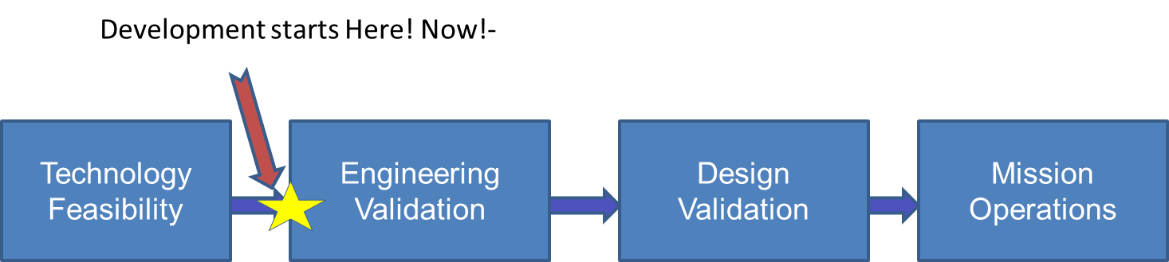
Enterprise activity at the Apex
The APEX is at the frontier. It is the line between mankind’s expanded earthly activities and the deep blue region of outer space.
As I mentioned in the previous Architecture Note (#34), ISEC foresees cargo flights departing from the Apex at least daily to the Moon, Mars, or other destinations in the solar system; It is expected that these cargo flight departures will be by “space carriers” (a prose extension of “air carriers”), or even container ships - conducting logistic missions to the destinations. Think United, Delta, and British Airways, or Maersk, APL, and the like. Since cargo delivery is the main theme maybe FedEx, UPS, or Amazon Prime can be visualized as enterprises at work within the Apex Enterprise Region.
These are businesses in the transportation world. The “space carriers” operating at the Apex will not be learning transportation on the job. Their Earth based transportation experiences of moving cargo from here to there will be applied at the Apex. There will be fundamental changes to be sure, but their entrepreneurial efforts at the Apex will be transportation based. The trick will be to adjust to space travel versus air or sea travel.
Predating the “transportation wise” space travel operations will be a period of operations simulations of all sorts. The cargo space-craft leaving the Apex will carry cargo properly loaded and secured, specialized thrusters will be affixed to support guiding the craft to its destination, and to stop when it gets there. The craft will have an array of guidance, navigation, and communications subsystems. The cargo will require a diverse set of protection from in route space environments. The on board computer will have any number of alternate flight plans to cover exigencies. And so much more - all provided by small, specialized enterprises.
At the Apex itself, we will see the essentials of interplanetary flights properly planned for cargo laden craft, readying for departure. As soon as the space carrier craft rotates into its departure vector, it will be released with enough ΔV to reach its destination, including orbit change maneuvers and such. The rotation of the planet Earth sets the departure moment. The departure point on a vector to Mars may be reached at 2300 hours UMT, and asteroid departure might at 0515 UMT. These times will be set and reset daily. The universe is moving about us!
The Apex is unique from other stations on the Harbour’s elevator. The essence of that uniqueness is that everything must be attached to the Tether or attached to whatever is attached to the Tether. Given that, we see an entire Apex Enterprise Region and the enterprises attached. The form of attachment is driven by some combination of the cargo arriving from the providers on the Planet Earth or from sources within the GEO Enterprise Region.
Deliveries arrive on the Climber – from the Planet Earth or from the GEO Enterprise Region – and are retrieved from the Climber. The cargo must then be taken to either the interplanetary cargo craft or to a cargo integration center. Both the cargo craft and the integration center must be attached; or else. Thus, part of the vision is that the integration centers and the various cargo craft are placed along a connecting tram-like pathway. Each delivery point - whether center or cargo craft – is expecting the particulars vouchered by manifest. These vouchers are actually generated by the Galactic Harbour’s supply chain management activity at the Earth Port’s Access City, another Architecture Note for another time.
The story told here is an Enterprise story; driven by the entrepreneurial forces that we all know so well. I am certain that the government’s role is clear to those who know well the import – export dynamics around the world today. Utilities like power, illumination, and surveillance are also part of the operations at the Apex. The Apex is the classic home for viewing outward, to “Outer Space”; and even viewing inward towards Earth. The Apex - the surveillance and situational awareness high point. One can only imagine what might be as we gaze … into this future.
In Closing
This is an incomplete story; and I suspect that many of you have not read much of it before. This is more the opening than the closing.
Fitzer

