Space Elevator Architecture
Architecture Note #27

Delivery of mission support logistics
-Essential for success-

Michael A. Fitzgerald
Senior Exec VP and Co-Founder
Galactic Harbour Associates, Inc
Space Elevator Transportation & Enterprise Systems

July 2019

Personal Prolog
This is an Architecture Note. It is the opinion of the Chief Architect. It represents an effort to document ongoing science and engineering discussions. It is one of many to be published over time. Most importantly, it is a sincere effort to be the diary, or the chronicle, of the multitude of our technical considerations as we progress; along the pathway developing the Space Elevator.
Michael A. Fitzgerald
Space Elevator Mission Support Equals Mission Success
The magnitude and scope of the Space Elevator Architecture demands that it be understood and supported by many. The envisioned Missions to Mars and the Moon are of incredible size and scope as well. There is a lingering taint to some discussions that these two behemoth efforts can only exist in sequence; first one. then the others.
However, what if it were found that one needed the other? Specifically, what if interplanetary missions were not possible without an operating Space Elevator? OR What if the scope and complexity of Interplanetary Missions made the currently envisioned Space Elevator inadequate in some way? There are probably a dozen variations to those questions; and the author’s position is that those variations should be documented in a thorough way and (subsequently) investigated; starting now
The first step is to begin a collaborative documentation & definition process by a small group from NSS, ISEC, NASA, NASM and others. It is expected that the group would build the “dozen variations’ alluded to in the previous paragraph. The team would then document appropriate study objectives, information standards, Interplanetary Mission requirements, Space Elevator capabilities, and other factors that are germane. This step would be called - “Study Documentation and Definition”.
Focused and collaborative efforts
The second step structures the study approach and the premises of the collaborative investigation studies. The primary premise is that interplanetary missions will be fully and completely supported by a Space Elevator Transportation System; almost concurrently.
Revealing my favorite mission approach a mission sequence of first, a pathfinding surveillance, discovery, and first landing effort at the destination (Moon or Mars – whichever). That effort is then rapidly -- almost concurrently -- reinforced by the logistics needed to sustain and grow that outpost.
This supportive, bootstrapped, almost concurrent mission effort has a permanent, place in our history; the World War II invasion of fortress Europe onto the beaches at Normandy. A little-known fact is that the entire follow up operation relied upon a secret and bold logistics strategy that had never been done before: building and shipping two entire sea ports (“Mulberry Harbours”) across the English Channel. This bold approach was an essential element of the brazen Allied invasion plan. In retrospect it made the Normandy invasion point obvious. These Mulberry Harbours allowed the Allies to ship massive quantities of men, materials, and supplies; supporting the relentless pressure on the retreating enemy.
Above, the term “almost concurrently” is used to signal quick follow-up. At Normandy, the first portions of the Mulberry Harbour were set in place within 72 hours of the initial assault; at two beaches. One Mulberry Harbour was complete and operating by June11; and the other by June 15.
In the first 6 months of their existence, the Normandy Beach Mulberry Harbours did their job, facilitating the transport of over 2.0 Million soldiers, 500,000 vehicles, and 3 Million tons of supplies. The logistic effort serviced the advancement of Allied forces into Germany and set the stage for victory and peace in Europe.

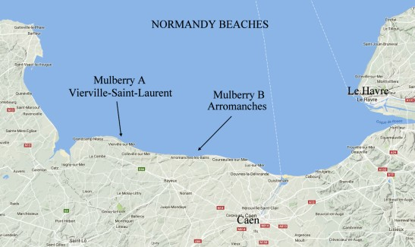

Focused and collaborative efforts plus history
We must apply this element of history to our efforts. A similar “almost concurrent” standard should be mandated for envisioned interplanetary missions. I predict a Moon Mulberry Galactic Harbour (i.e. including its own Space Elevator) will be built and be receiving sustainment materials; supporting the outpost that will re-established on our return trip to the Moon. The Mars Mulberry Galactic Harbour will follow quickly.
It will take one kind of effort to get mankind to the destinations (planet, moon, or asteroids) and another kind of effort to sustain and grow those outposts. A sequence of efforts is called for and consideration ought to be to sequence the pathfinding to the right destination first, then support it; “almost concurrently”. That accomplished a second destination be identified and agreed to with and enabled by the Space Elevator Transportation System.
In this collaboration, it is important that the Space Elevator be seen as a TRANSPORTATION SYSTEM! This effort is about the Space Elevator Transportation System as the affordable and dependable access to space. We must keep our vision in mind. After we get the transportation system; businesses on orbit will flourish. The collaboration efforts proffered here are important, yet any number of follow-on efforts are needed. Let’s Start Collaborating Now
In Closing
The Mulberry Harbours were a magnificent development; birthed from a collaborative effort led by United Kingdom maritime engineers. The parallel here is just too powerful to ignore. ISEC must reach out; seeking to coordinate and reach agreements with a variety of players. We should be humbled and grateful by the efforts that saved the world then; and repeat all of that with a collaborative sinew stronger than the Elevator’s tether.

Just Saying
Fitzer

